The Levitical Tabernacle Was Earthly
Hebrews 9:1-5

Introduction:

Triple Division Pre-dates Moses.

Egyptian Ruins: Temple

Outer court – worshippers brought sacrifices
Second region – priests worked
Inner court – a statue of the goddess.

Uncivilized Tribes: Todas – worshipped buffaloes

Outer court
Through a low door to a room where mourners could go
The inner part where only the chief dairy man could go.

These pre-date Moses indicating that God must have revealed the way man could approach Him after the fall.

Pictures Heavenly Temple

The earth is the outer court

The One Sacrifice has been offered.
Through confession believers are cleansed.

The outer heavens

The Holy Spirit (and even angels) ministers for us.

The true Tabernacle

Our High Priest has already entered.

Three veils
The entrance of the courtyard
The entrance of the Holy place
The entrance of the Holy of Holies
- The Courtyard
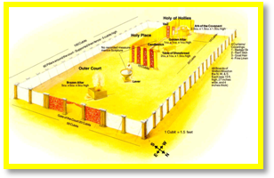
The materials in the tabernacle included a little over a ton of gold (38:24), almost four tons of silver (vv. 25-28), and about two and one-half tons of bronze (vv. 29-31; cf. niv marg.).

- The Fence

150 feet by 75 feet—
7 feet high linen coverings
Gate on the East side -- First Veil

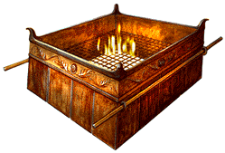
- The Contents

- The Brazen Altar - The people brought their animals for sacrifice.

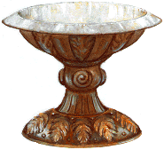
- The Laver – Priests washed there before entering into the Holy Place

- The Significance

Since the death of Christ, the believer can enter into the presence of God. But he must come through the “courtyard”

By the altar of sacrifice – Jesus Christ – Salvation

By the laver – confession and forgiveness of sins - Sanctification

Hebrews 10:19-22
“Therefore, brethren, having ﻿﻿boldness ﻿﻿to enter ﻿﻿the Holiest by the blood of Jesus, by a new and ﻿﻿living way which He consecrated for us, through the veil, that is, His flesh, and having a High Priest over the house of God, let us ﻿﻿draw near with a true heart ﻿﻿in full assurance of faith, having our hearts sprinkled from an evil conscience and our bodies washed with pure water.”
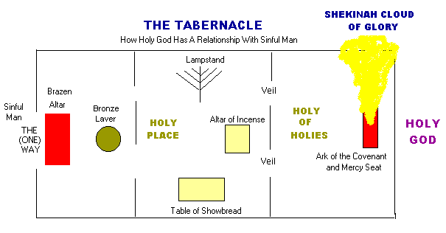
- The Holy Place

- The Dimensions

30ft. /15ft

- The Contents

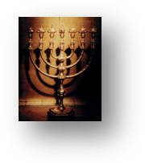
- Lamp Stand

  - Trimmed daily
  - Oil added
  - Gave light for service

- Showbread

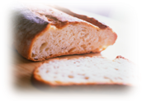
  - Twelve loaves –one for each tribe.
  - Stayed there from Sabbath to Sabbath
  - It was then eaten by the priests - only

- The Significance

- The lamps

Jesus is the light of the world - John 8:12

We are the light of the world - Matthew. 5:14

Don’t put it under your bed - Mark 4:16
﻿
“No one, when he has lit a lamp, covers it with a vessel or puts it under a bed …

Your lamp is your eye - Matthew 6:22
﻿﻿
“The lamp of the body is the eye. If therefore your eye is ﻿﻿good, your whole body will be full of light.

- Jesus is the bread of life – John 6:35

“And Jesus said to them, ﻿﻿“I am the bread of life. He who comes to Me shall never hunger, he who believes in Me shall never ﻿﻿thirst.”

We feed on the Living Word through the written Word.

We are saved by the Word – I Peter 1:23

“having been born again, not of ﻿﻿corruptible seed but ﻿﻿incorruptible, ﻿﻿through the word of God which lives and abides ﻿﻿forever,

We grow through the Word – I Peter 2:2

“as newborn babes, desire the pure ﻿﻿milk of the word, that you may grow ﻿﻿thereby,”

- The Holy of Holies

Remember that the Epistle to the Hebrews is written with the Day of Atonement in mind.
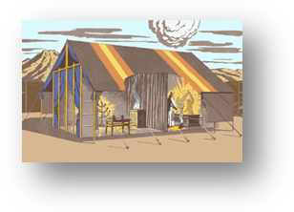
- The Dimensions - 15ft/15ft

It was half the size of the Holy Place.

- The Contents

- The Golden Censer (The Altar of Incense).

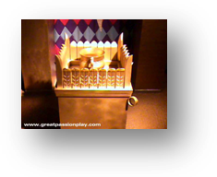
The priest carried a shovel of coals from the Altar of Incense with him into the Holy of Holies so that he could not see clearly the Lord between the Cherubim.

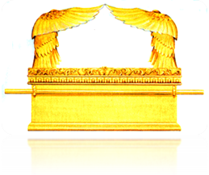
- The Ark of the Covenant

- Inside

1) The pot of manna

Exodus 16:3
“Fill an omer with it, to be kept for your generations, that they may see the bread with which I fed you in the wilderness, when I brought you out of the land of Egypt.

2) Aaron’s rod – Numbers 17:8-10

History of the Rod

The rebellion of Korah

The test of the 12 rods

﻿“Now it came to pass on the next day that Moses went into the tabernacle of witness, and behold, the rod of Aaron, of the house of Levi, had sprouted and put forth buds, had produced blossoms and yielded ripe almonds. Then Moses brought out all the rods from before the Lord to all the children of Israel; and they looked, and each man took his rod.”

3) Tables of stone – Exodus 34:29

The first set was broken.

God gave a second set. These were in the ark.

- Outside

1) Cherubim – living creatures Exodus 25:17-18
﻿
“You shall make a mercy seat of pure gold; two and a half cubits shall be its length and a cubit and a half its width. And you shall make two cherubim of gold; of hammered work you shall make them at the two ends of the mercy seat.

2) Mercy seat -ἱλαστήριον כַּפֹּרֶת Heb. = covering

﻿“You shall put the mercy seat on top of the ark, and ﻿﻿in the ark you shall put the Testimony that I will give you.”

- The Significance

Tablets – He is the God of the second chance.

Aaron’s rod – God chooses priests.

Mercy seat – The wages of sin is death.

Over-all meaning -God dwells with His People.

Conclusion:

